Assignment - 1

|  |  |
| --- | --- |
| **Student Name/ID Number:** | Agung Yuda Pratama/BDSE-0922-076 |
| **Academic Year:** | 2022 |
| **Module Name:** | Front End Web Development |
| **Project Title:** | Information Architecture, Wireframe and Story Board |
| **Submission Date:** | 26-09-2022 |

Date:

Student signature:

I certify that the work submitted for this assignment is my own and research sources are fully acknowledged.

**Learner declaration**

26-09-2022

Agung Yuda Pratama

|  |
| --- |
| **Purpose of this project** |
| **Purpose of this project**  To demonstrate your capabilities in the following areas:   * Plan a Website & Develop branding, wireframes, information architecture & storyboard. |
| **Submission Format** |
| In one document, submit the following:   1. Information Architecture, 2. Wireframe, and 3. Storyboard |
| **Project Brief & Guidance** |
| **Scenario:**  You have been approached by ‘ABC Learning Center’ as a website developer to develop a  company portfolio website for their institute. ‘ABC Learning Center’ is an IT Training institute that conducts courses like ‘Programming in Java’, ‘Programming in .Net’,  ‘Microsoft Office’, ‘HTML’ etc. They want to design a website which can be used for  providing information about their courses to students.  You will be required to design and develop this website using HTML, JavaScript, and CSS. For Assignment 1, you will be required to design following pages for the website –   1. Common Content    1. Header    2. Footer    3. Navigation 2. Home Page 3. About Us Page / Profile Page 4. Contact Us Page (Develop 1 Html page) 5. Course Details Page (Develop 2 pages, 1 for each course) 6. Course Schedule Page (Develop 2 pages, 1 for each course) 7. Sitemap Page (Develop 1 HTML page) 8. Privacy Policy Page (Develop 1 HTML page) |

**Information Architecture of ABC Learning Center**

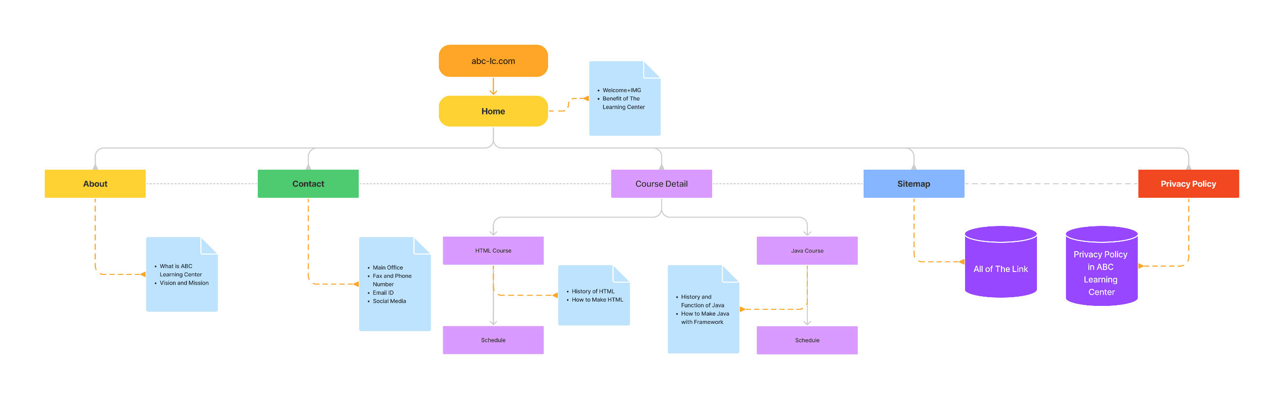

**Wireframe**

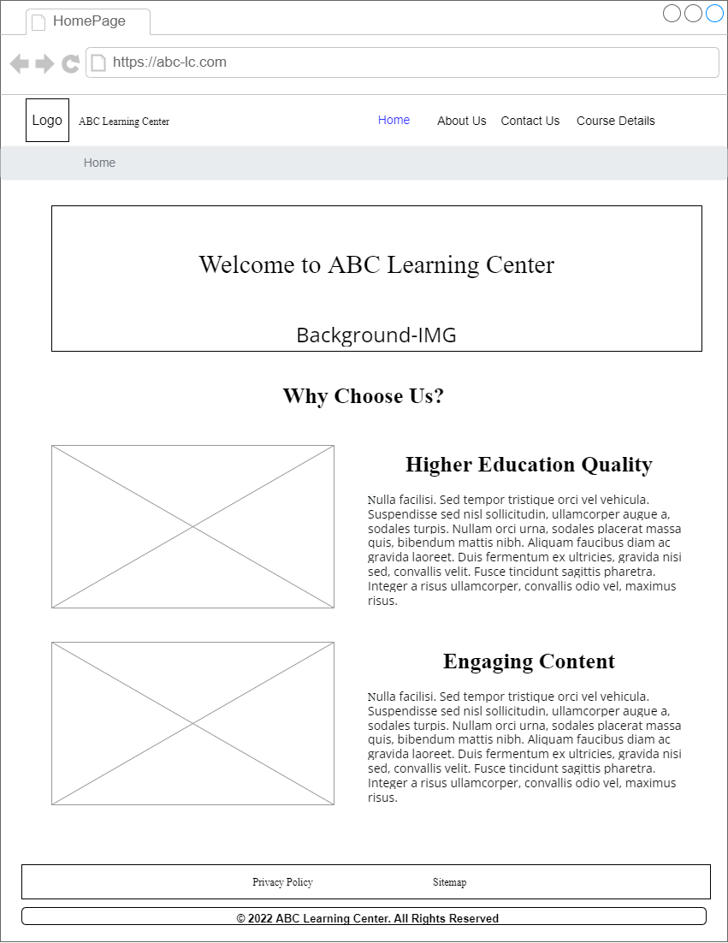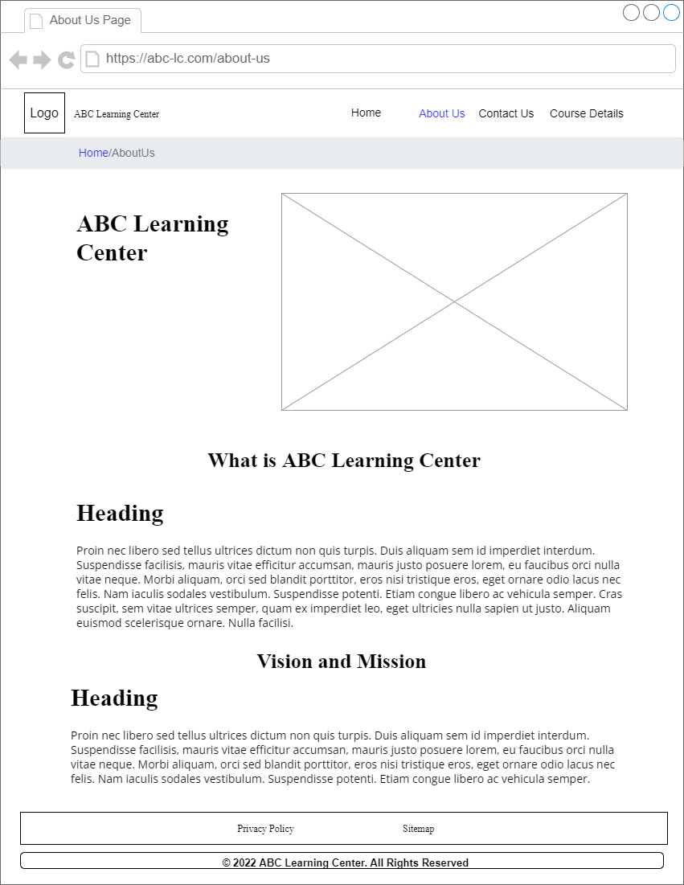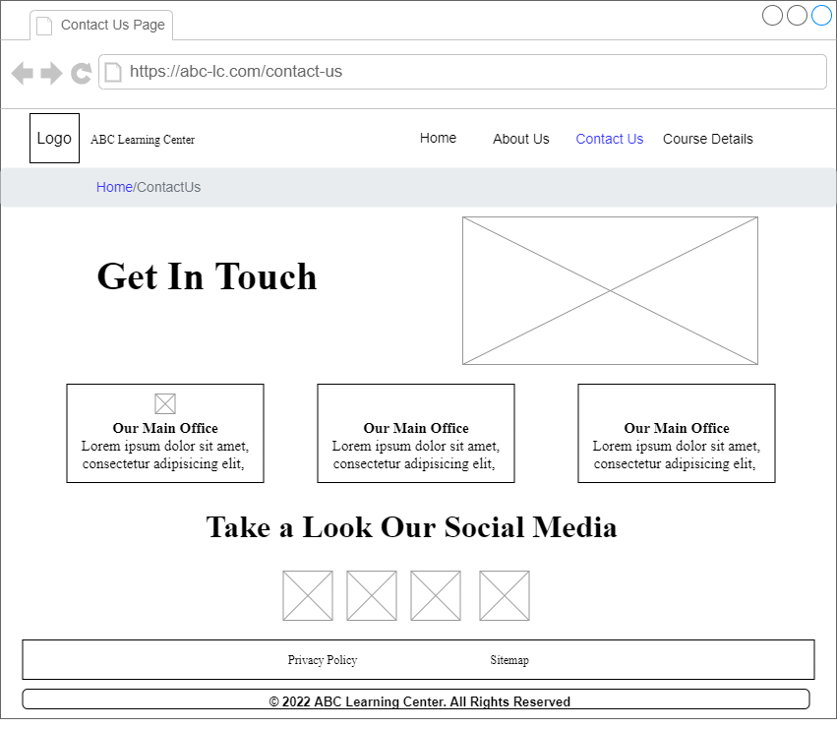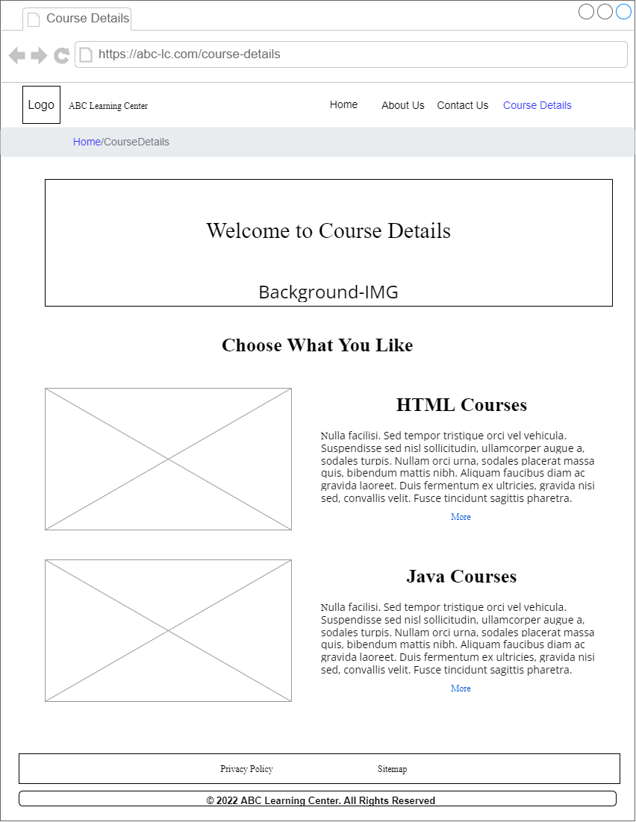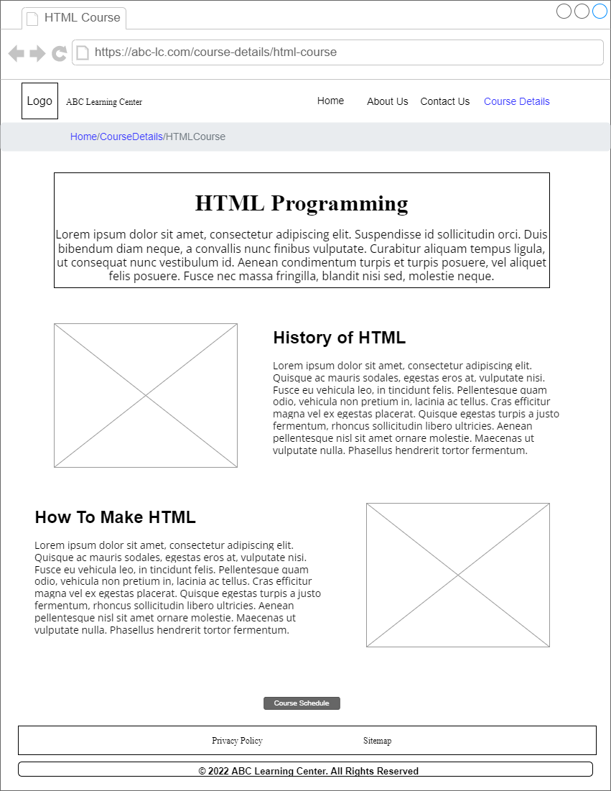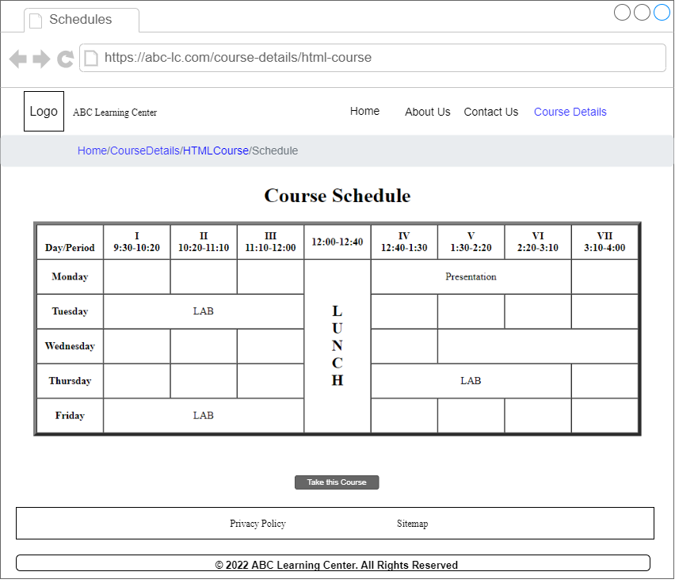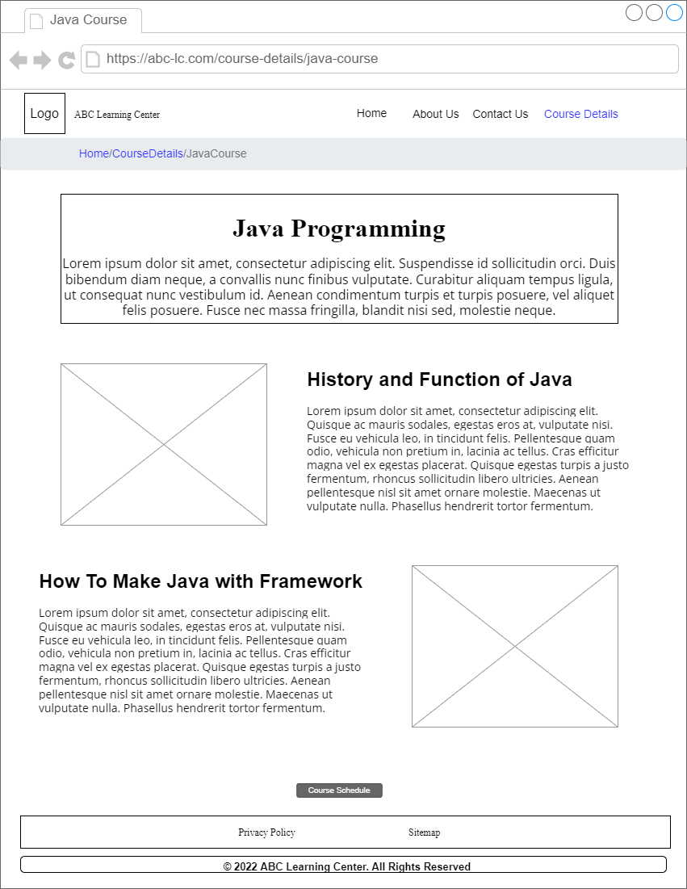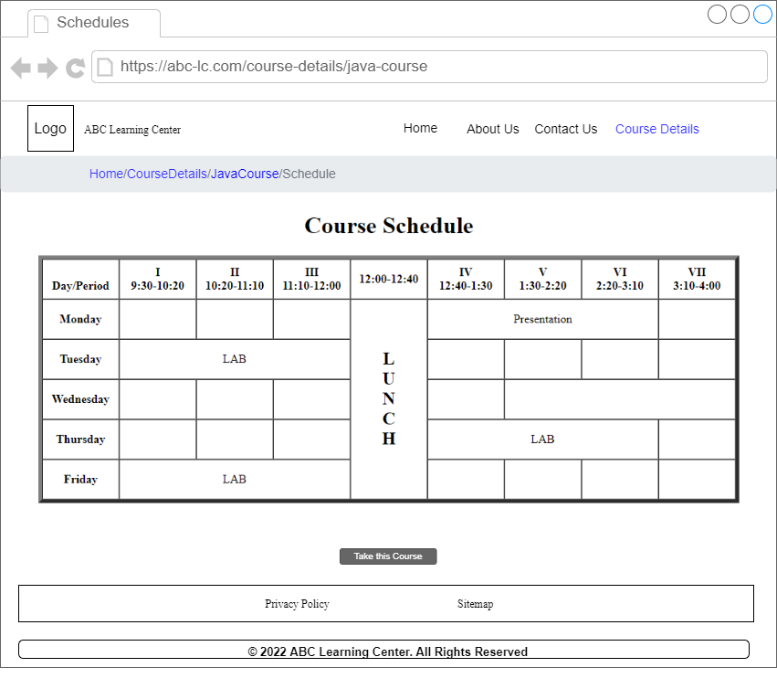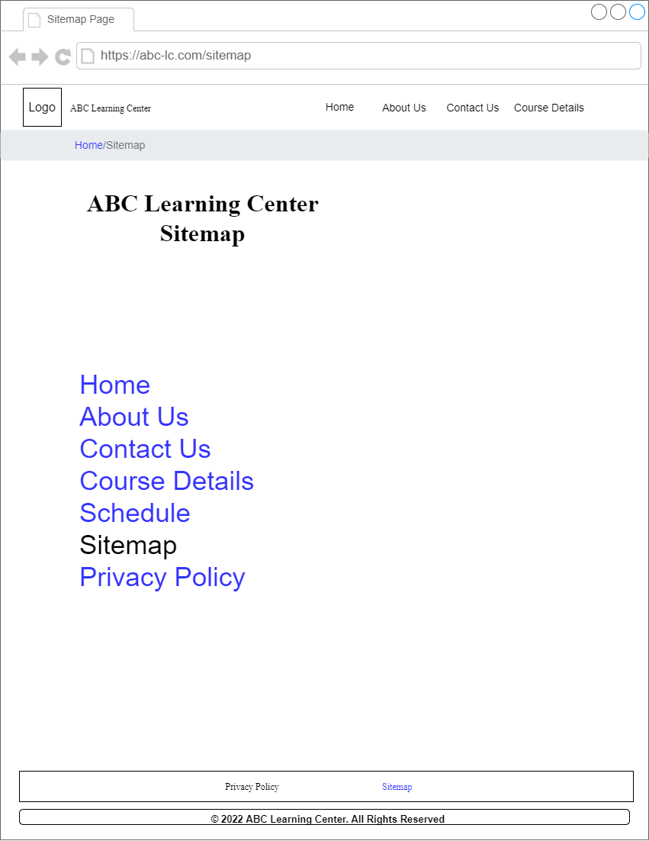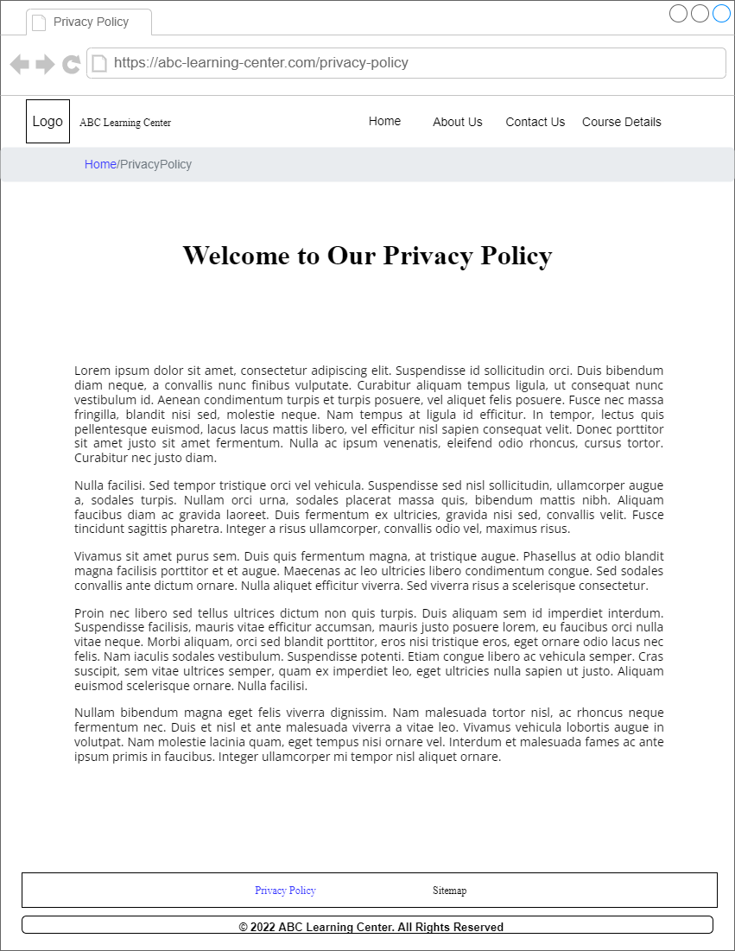

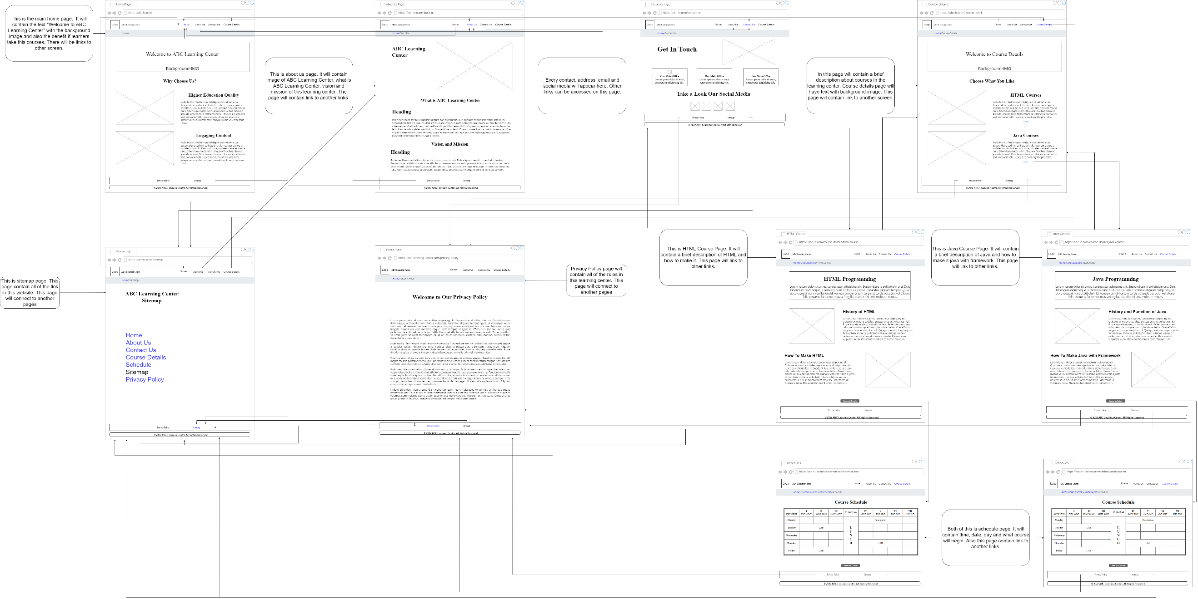**Storyboard**